System Sequence Diagrams

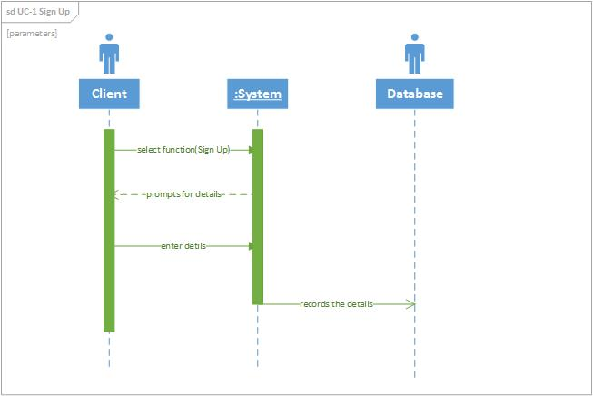

Figure 1 Sequence Diagram of Use Case 1

Figure 4-1 shows the sequence diagram of Use Case 1 which is “Sign Up”. It is used to create new client’s accounts. First the client clicks the “Sign Up” hyperlink. Next, the system prompts the client to enter their details. Then the client enters the required details. After that the system records the data into the database.

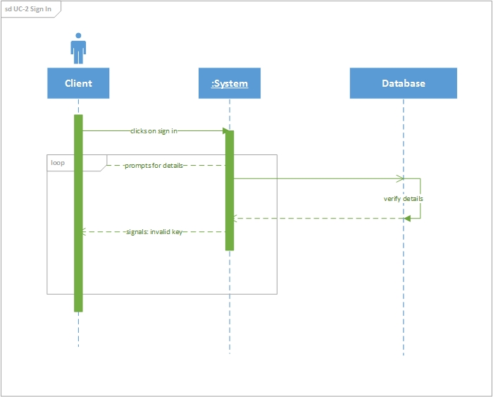

Figure 2 Sequence Diagram for Use Case 2

Figure 2 shows the sequence diagram of Use Case 2 which is “Sign In”. It is used to sign in clients. First the client clicks the “Sign In” hyperlink. Next, the system prompts the client to enter their details. Then the client enters the required details. After that the

System prepares a database query to verify whether the details provided are valid.

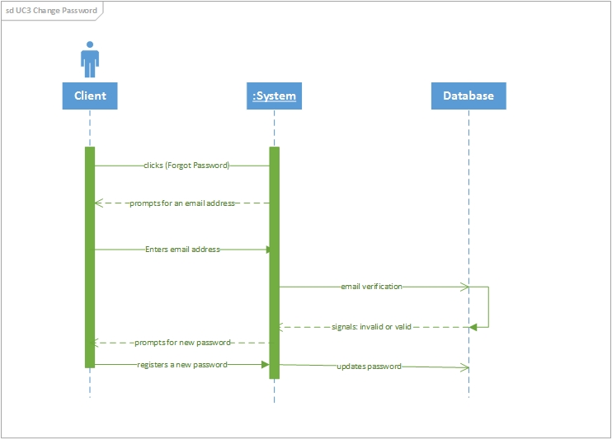

Figure 3 Sequence Diagram for Use Case 3

Figure 3 shows the sequence diagram of Use Case 3 which is “Sign In”. It is used to change a client’s password. First, the clients clicks the “Forgot Password” hyperlink and the system will prompt the client to enter a registered password. The system prepares a database query to verify whether the email address provided is in the database. If the email address is found in the database, then an email will be sent to the client with a link that when clicked will direct the client to a page where they can register a new password. Then after that the system will prepare another database query to update the old password.

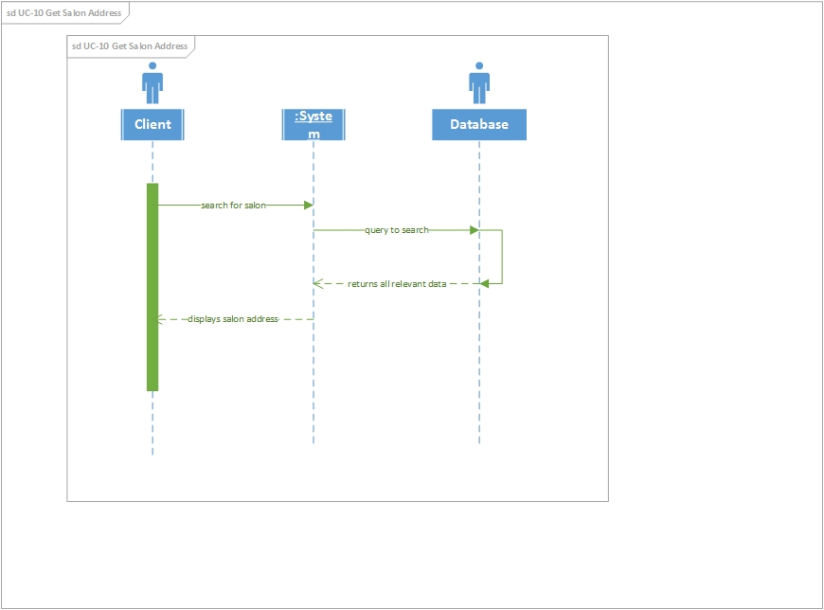

Figure 4 Sequence Diagram for Use Case 10

Figure 4 shows the sequence diagram of Use Case 10 which is “Get Salon Address”. It is used to get salon’s addresses. First, the clients searches for the salon either by hair-style, location or by price range. Then after that the system will allow the client to select the salon of their choice. Then the system will display the salon address.